CSEN 241 Cloud Computing
HW3

Rohan Pandey W1644990 rpandey4@scu.edu

Task 1: Defining custom topologies
Questions
1. What is the output of “nodes” and “net”
Ans:- nodes-
net
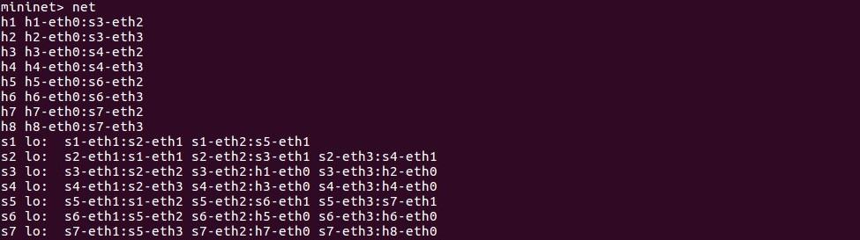
2. What is the output of “h7 ifconfig”
Ans:-
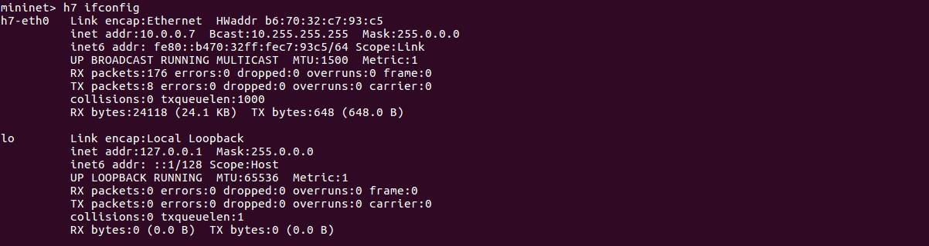

Task 2: Analyze the “of_tutorial’ controller
Questions 1:-Draw the function call graph of this controller. For example, once a packet comes to the controller, which function is the first to be called, which one is the second, and so forth?
Ans:- Start with- POX by running the following commands:
$ ./pox.py log.level --DEBUG misc.of_tutorial
Initiating this command activates the 'start switch'. The 'start switch' then invokes the '_handle_PacketIn()' method, which processes the incoming packet message from the switch. Subsequently, '_handle_PacketIn()' triggers the 'act_like_hub()' method. This method dispatches packets to every port other than the one where the packet was received, mimicking the behavior of a hub. Following this, the 'resend_packet()' method is executed, which appends a packet to the message payload and applies the necessary action. Finally, the switch receives instructions from this message to forward the packet to a designated port.
Diagram for function call graph :-
The flow would be ->
start switch : _handle_PacketIn() -> act_like_hub() -> resend_packet() -> send(msg)
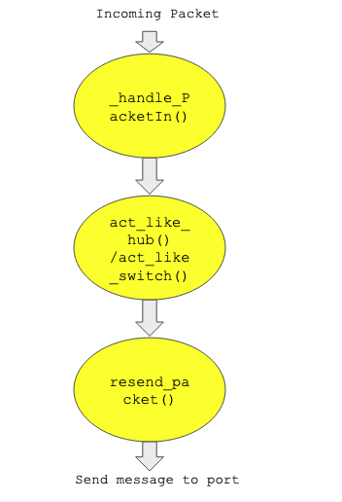

2. Have h1 ping h2, and h1 ping h8 for 100 times (e.g., h1 ping -c100 p2).
Ans:- h1 ping -c100 h2:
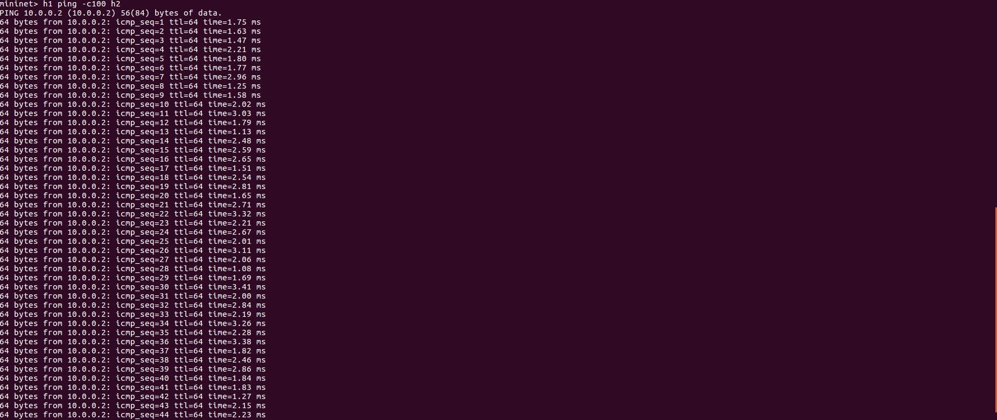
h1 ping -c100 h8:
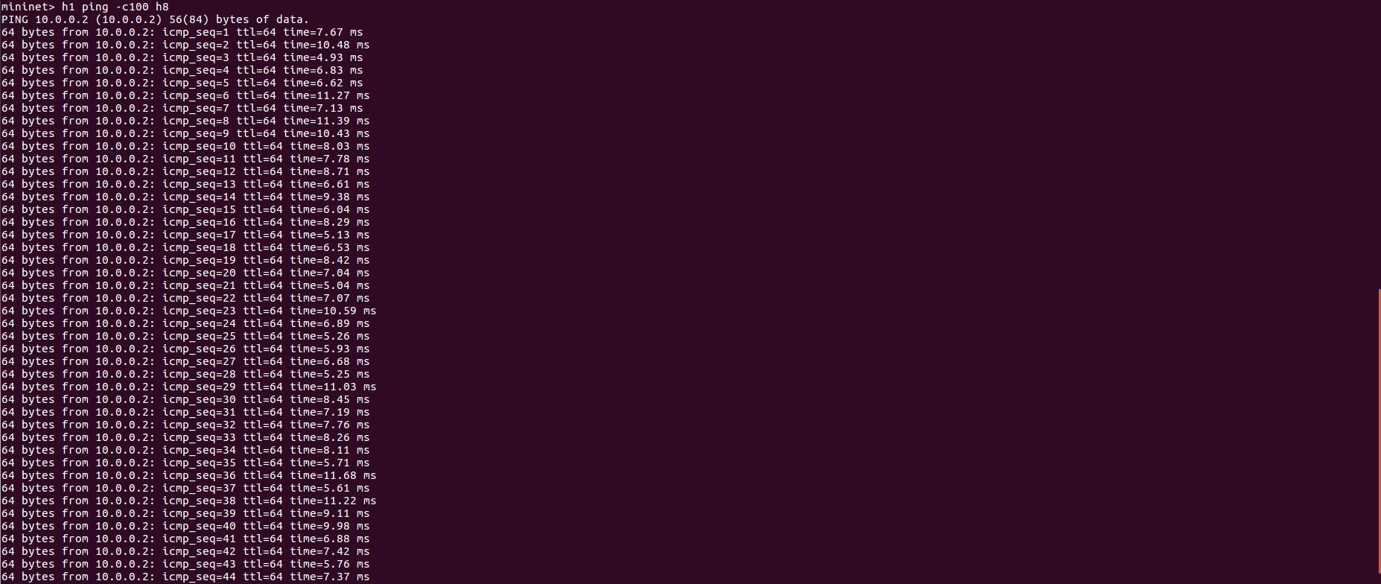
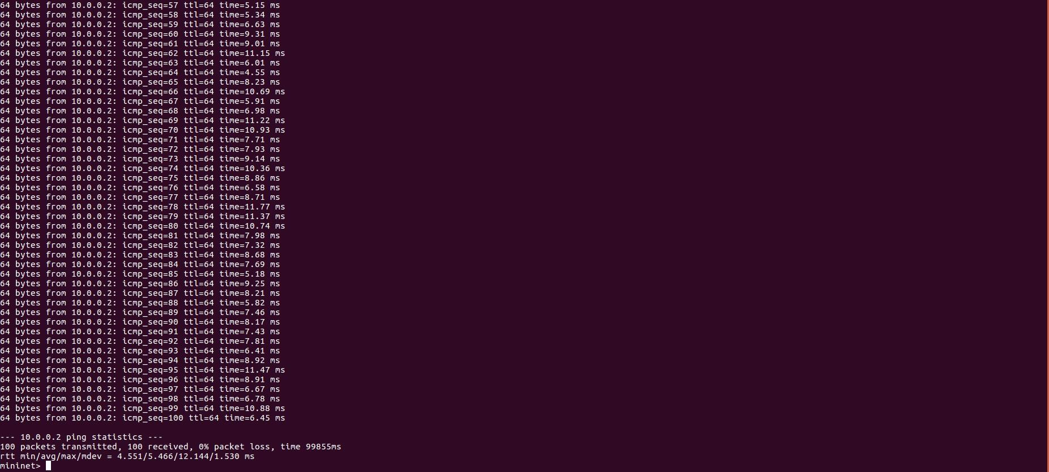
a. How long does it take (on average) to ping for each case?
Ans:- Average Ping-
- h1 ping h2 => 1.66 ms
- h1 ping h8 => 5.50 ms
b. What is the minimum and maximum ping you have observed?
Ans:- Average Ping-
- h1 ping h2 => 1.10 ms (Minimum) & 3.41 ( Maximum)
- h1 ping h8 => 4.55 ms (Minimum) & 12.14 ( Maximum)
c. What is the difference, and why?
Ans:- The ping duration from h1 to h8 is greater than that from h1 to h2. This is due to the fact that h1 and h2 are connected by a single switch, s3, while the connection between h1 and h8 involves multiple switches - specifically, s3, s2, s1, s5, and s7, creating several hops.
3. Run “iperf h1 h2” and “iperf h1 h8”
Ans:- Output->
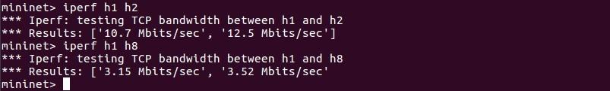
a. What is “iperf” used for?
Ans:- iperf is a free tool that assists administrators in assessing the bandwidth and the quality of a network connection. The utility confines the network link between two hosts that run iperf. It serves to gauge the data transfer rate between any two points within a network pathway.
b. What is the throughput for each case?
Ans:-
mininet> iperf h1 h2
*** Iperf: testing TCP bandwidth between h1 and h2
*** Results: ['10.7 Mbits/sec', '12.5 Mbits/sec']
mininet> iperf h1 h8
*** Iperf: testing TCP bandwidth between h1 and h8
*** Results: ['3.15 Mbits/sec', '3.52 Mbits/sec'
c. What is the difference, and explain the reasons for the difference.
Ans:- The data transfer rate from h1 to h2 is greater than from h1 to h8 due to network congestion and latency, similar to the increased ping time. With fewer hops between h1 and h2, data transmission is more efficient, allowing for higher throughput in less time. Conversely, the greater number of hops from h1 to h8 leads to a reduction in data transmission over the same time period.
4. Which of the switches observe traffic? Please describe your way for observing such
traffic on switches (e.g., adding some functions in the “of_tutorial” controller)
Ans:- Placing the code log.info("Switch observing traffic: %s" % (self.connection)) at line number 107 in the "of_tutorial" controller enables us to monitor the traffic flow. Observations reveal that all switches are subject to traffic inspection, particularly when they are inundated with packets. Since the _handle_PacketIn function acts as an event listener, it is invoked each time a packet arrives.

Task 3: MAC Learning Controller
- Describe how the above code works, such as how the "MAC to Port" map is established. You could use a ‘ping’ example to describe the establishment process (e.g., h1 ping h2).
Ans:-
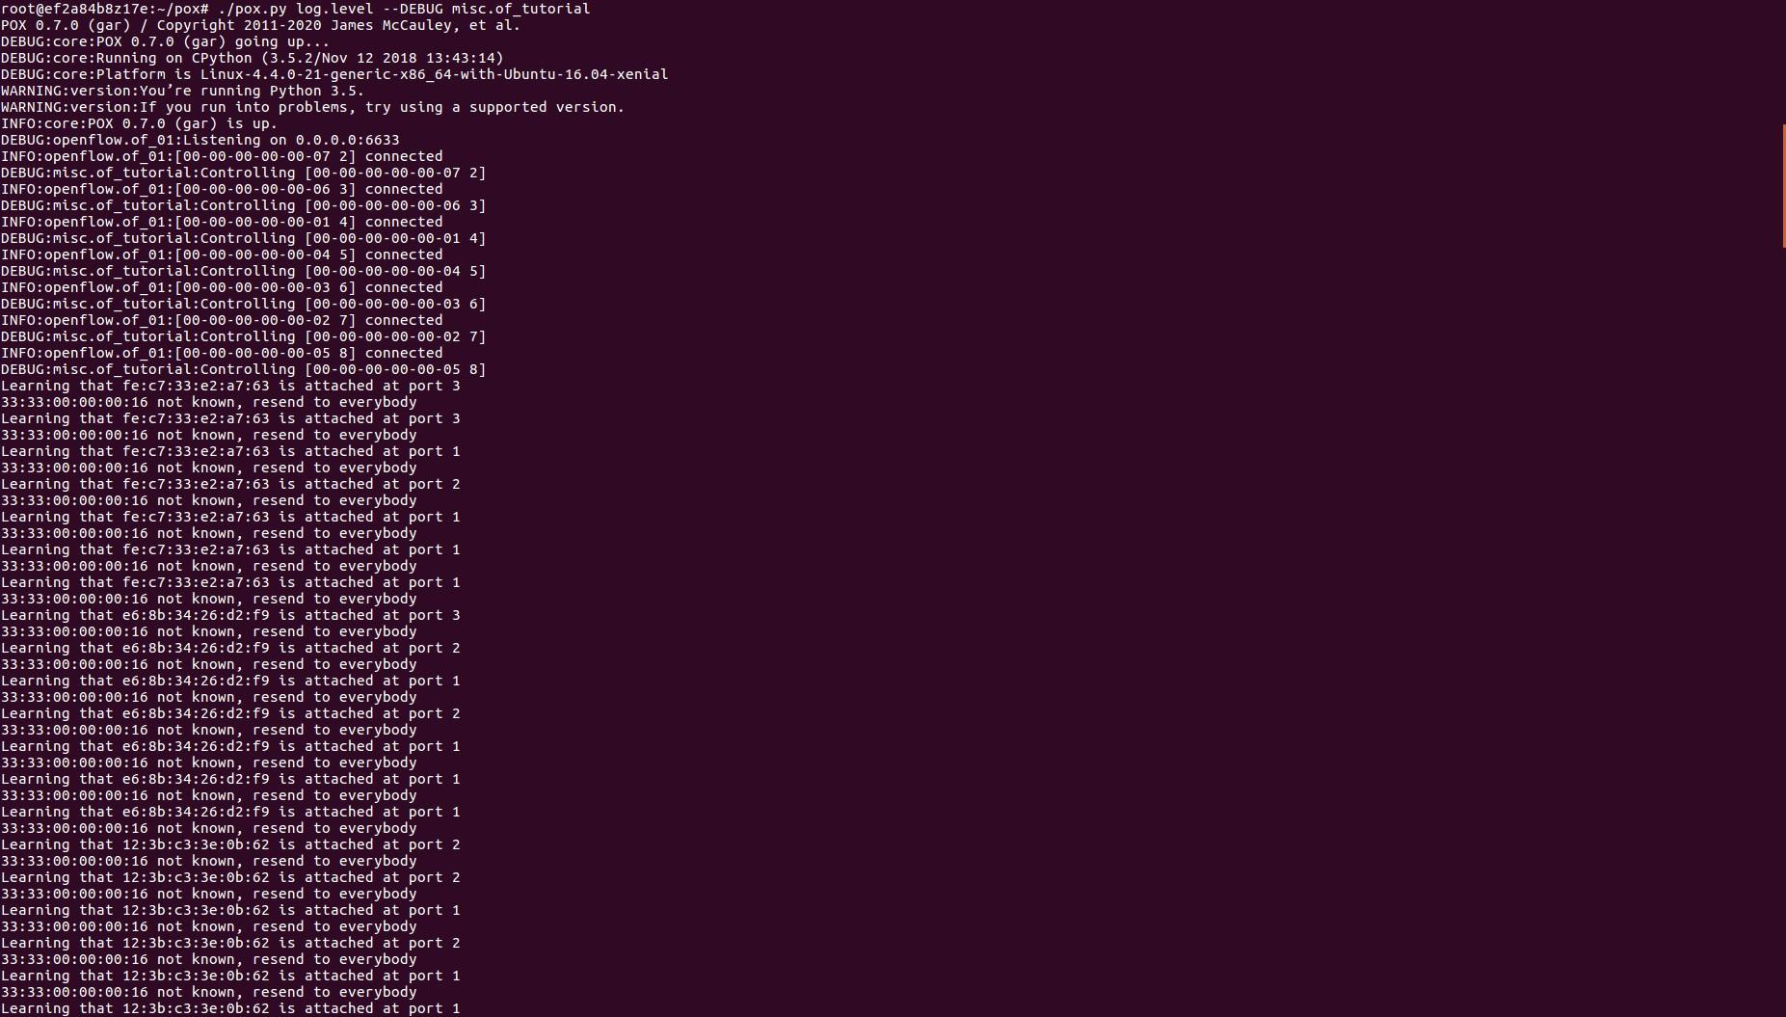
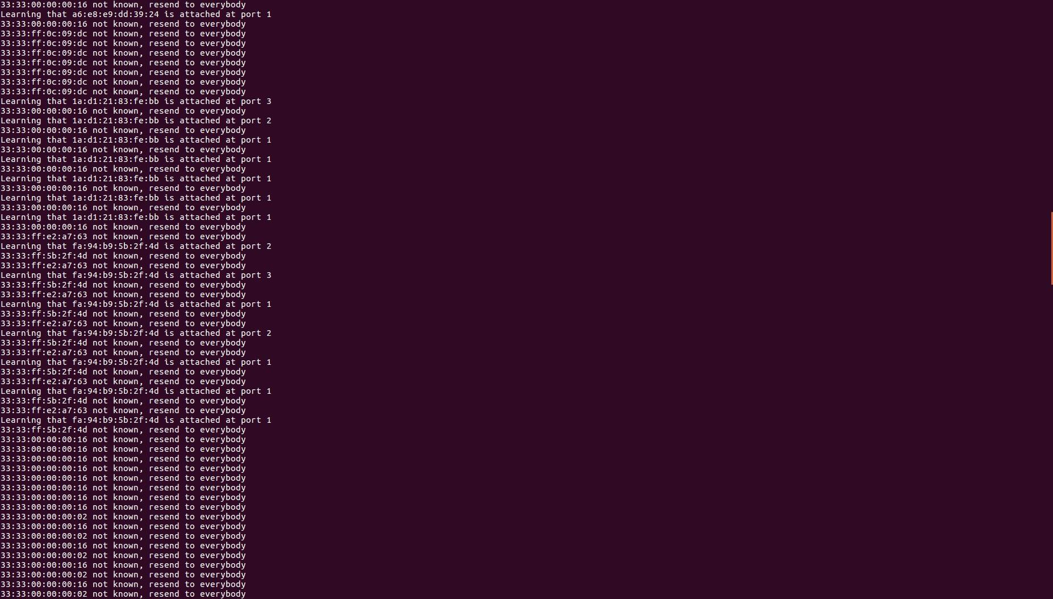

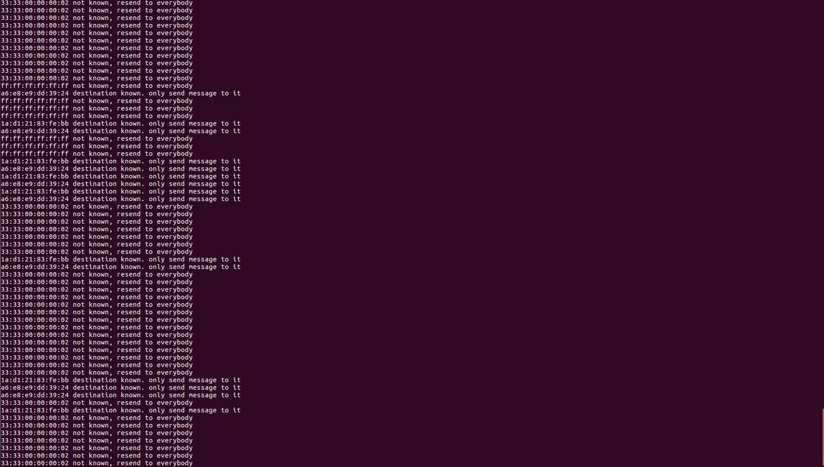
- (Comment out all prints before doing this experiment) Have h1 ping h2, and h1 ping h8 for 100 times (e.g., h1 ping -c100 p2).

h1 ping -c100 p2
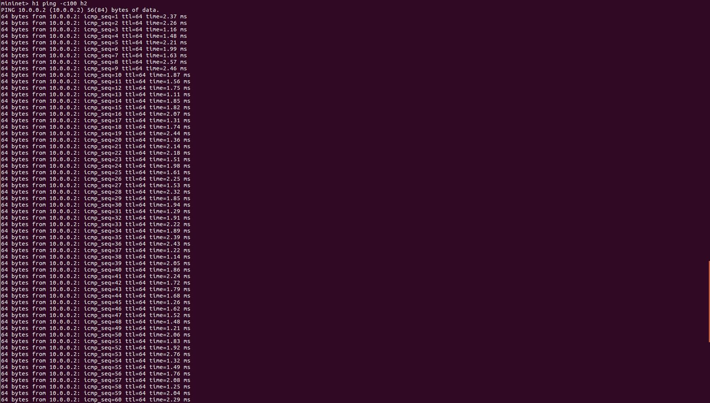
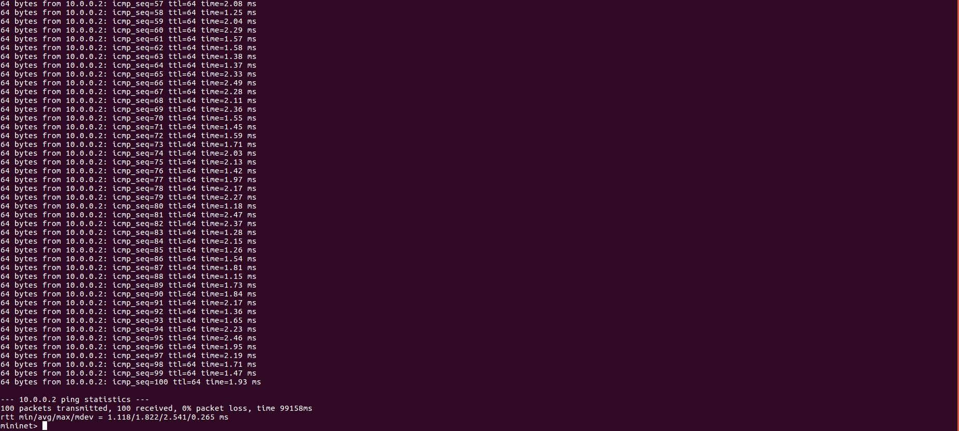

h1 ping -c100 h8
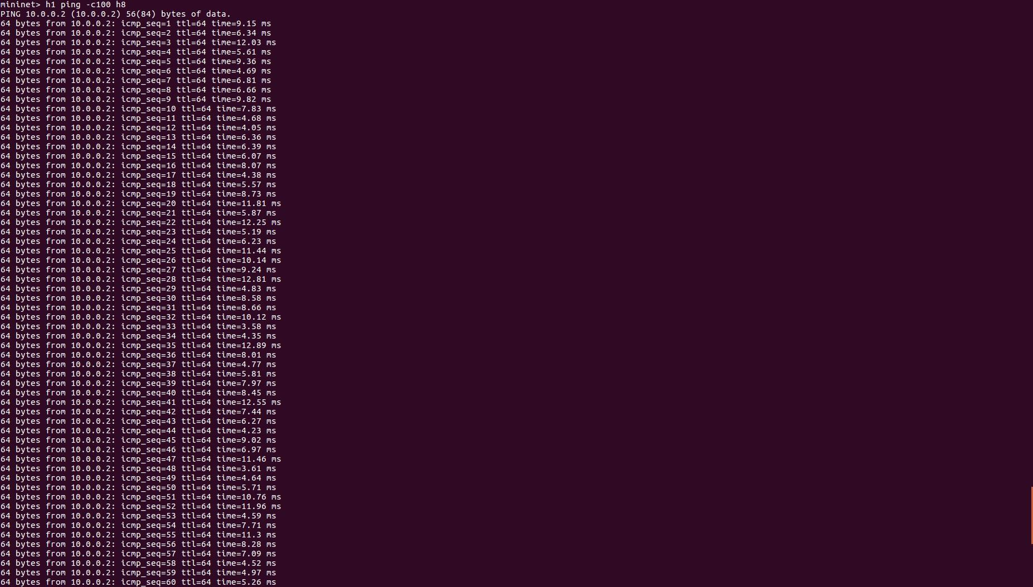
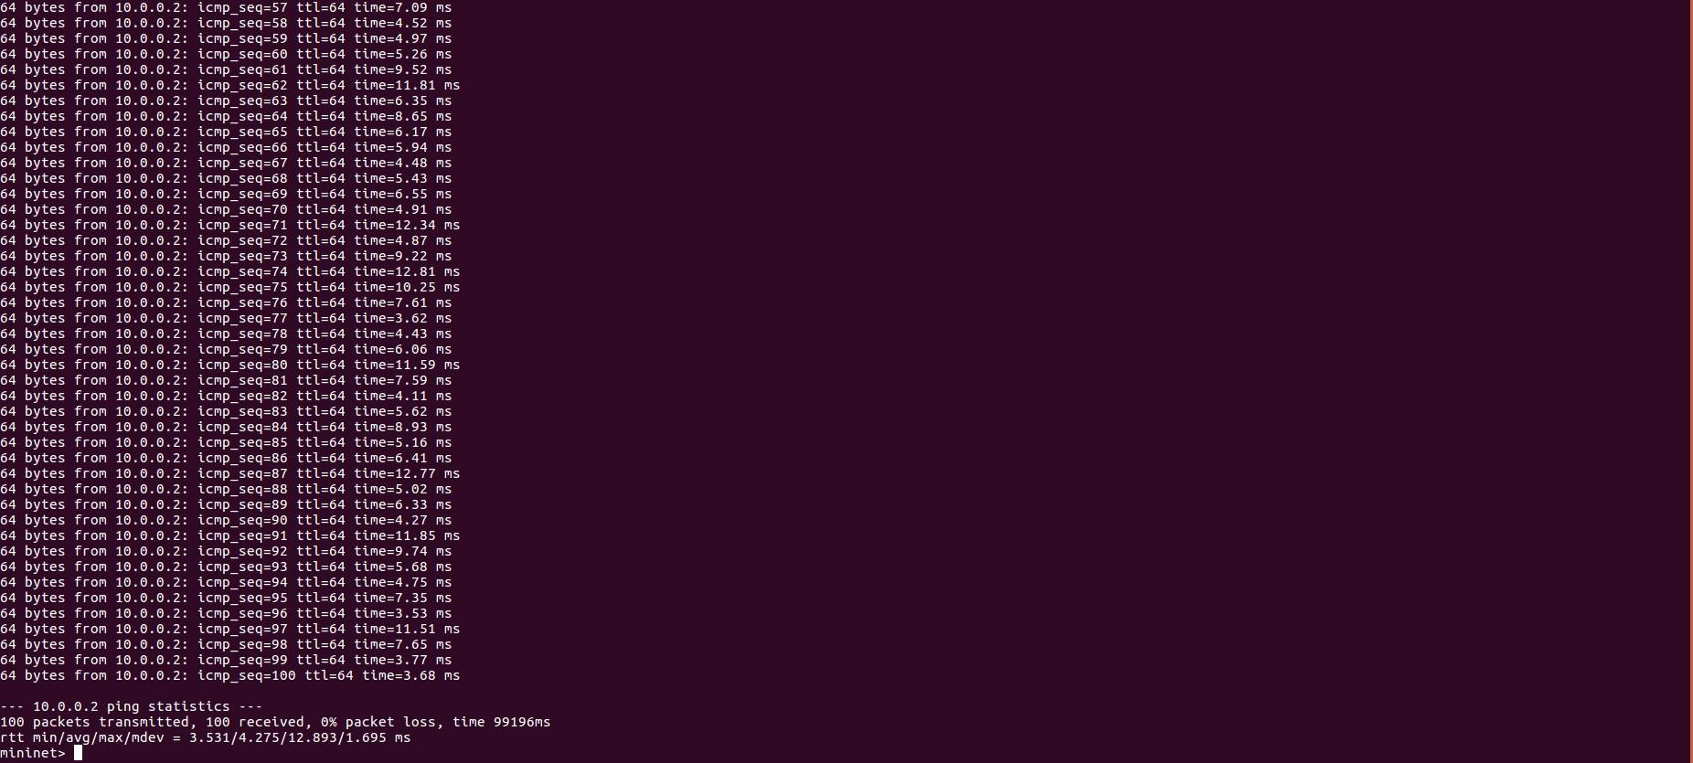
  - How long did it take (on average) to ping for each case?
Ans:- Average Ping-
- h1 ping h2 => 1.82 ms
- h1 ping h8 => 4.27 ms
  - What is the minimum and maximum ping you have observed?

Ans:- Average Ping-
- h1 ping h2 => 1.12 ms (Minimum) & 2.54 ( Maximum)
- h1 ping h8 3.53 ms (Minimum) & 12.89 ( Maximum)
  - Any difference from Task 2 and why do you think there is a change if there is?
Relative to task 2, the ping times for h1 to h2 in task 3 are marginally quicker, with the discrepancy being minor. In contrast, the ping times between h1 and h8 show a marked improvement in task 3, which can be attributed to the additional switches that the packets traverse. The reduced ping times in task 3 result from the limited flooding of the initial packets. After the switch learns the destination's MAC address and records it in the "mac_to_port" map, it forwards subsequent packets directly to the associated port. Consequently, later pings benefit from swifter delivery times due to reduced network traffic.
- Q.3 Run “iperf h1 h2” and “iperf h1 h8”
  - What is the throughput for each case?
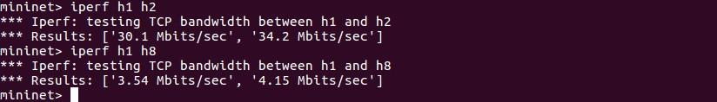
  - What is the difference from Task 2 and why do you think there is a change if there is?
The data transfer rates in task 3 outperform those in task 2 for both scenarios, owing to reduced network congestion. In task 3, once the "mac_to_port" map has identified all relevant ports, packet flooding ceases, thereby alleviating strain on the switches. For connections between h1 and h2, tasks 1 and 2 exhibit an average throughput that is nearly triple that of task 3, benefitting from more efficiently pre-determined routes because of enhancements in the controller logic. Although the improvement is less pronounced for the h1 to h8 connection, there is a slight enhancement in throughput, which can be attributed to a reduced number of hops and less packet loss.

Git Repository Information:

Account name | rohanpandeymech
Repository name | COEN-241-Cloud-Computing
Folder which contains HW3 | HW3/
Link to repository | https://github.com/rohanpandeymech/CloudComputing/tree/main
Commit ID

